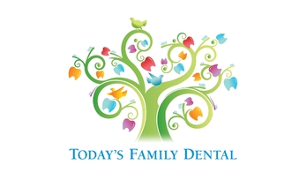
Patient Advisory and Acknowledgement
Receiving Dental Treatment During COVID-19 Pandemic
Thank you for putting your trust in our office and we are so glad we are able to see you again. This form allows us to screen for communicable diseases including COVID-19 in our office in an effort to keep all our patients and team safe.
While our office complies (even exceeds) with State Health Department and CDC infection control guidelines to prevent the spread of Covid-19, we cannot make any guarantees. All members of our team are symptom free and to the best of our knowledge have not been exposed to the virus. However, since we are a place of public accommodation, other persons could be infected without their knowledge. In order to reduce the risk of spreading Covid-19, we have several screening questions below that we need you to answer. For the safety of our team and yourself, please be truthful and candid in your answers.
Email: ___________________ Phone number: ____________________
Patients full name: _____________________ Today’s Temperature: _____________
- Have you travelled in the last 14 days? Yes/No
  - If Yes, was it Domestically or Internationally? (Please Circle One)
Where? ___________________________
  - Have you been Vaccinated for COVID-19? Yes/No
If so, when? Part 1_______________ Part 2 ______________
- Have you recently tested positive COVID-19? Yes / No
If so, When? _______________
- Have any members of your household tested positive for COVID-19? Yes/No If so, when? __________________.
- Did you have a fever during the last 14 days? Yes/No
- Did you have any shortness of breath during the last 14 days? Yes/ No
- Did you have a sore throat during the last 14 days? Yes/No
- Do you have any loss of taste or smell during the last 14 days? Yes/No
- Did/do you have any new muscle pain during the last 14 days? Yes/No
- Did/do you have any unusual headaches during the last 14 days? Yes/ No
- Did/Do you have a cough in the last 14 days? Yes/No
- Did/Do you have any nausea during the last 14 days? Yes/No
- Did you have any vomiting during the last 14 days? Yes/ No
- Did you have any Diarrhea during the last 14 days? Yes/ No
I understand that if the answers to any of these questions is yes, I may be asked to reschedule today’s dental appointment. Please sign/type your full name below.
___________________________________________________________ patient signature

